**Course Name:** CMPE-272-Enterprise Software Platforms

**Student Name:** Shalini Negi

**Student ID:** 010652980

**Assignment # 8:** Mule project

**Semester:** Fall, 2015

**Objective:**

This document demonstrates how to download, install and launch Anypoint Studio. Also, to build hello world application and upload to git.

**Download and install Anypoint Studio:**

1. Download Anypoint Studio. Link to download is <https://docs.mulesoft.com/mule-fundamentals/v/3.7/download-and-launch-anypoint-studio>

2. Open Anypoint Studio. In my case, I have a mac so double-click the AnypointStudio file, located in the AnypointStudio folder.

3. Click **OK** to accept the default workspace.

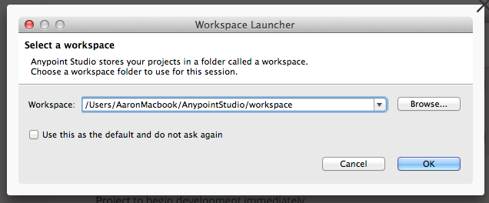

**Build a hello world application:**

In order to build hello world application follow these steps :

1. Create a new project

1.1. Click **File** then select **New** > **Mule Project**.

1.2. Studio opens the **New Mule Project** wizard. In the **Name** field, enter the value My First Project, then click **Finish**.

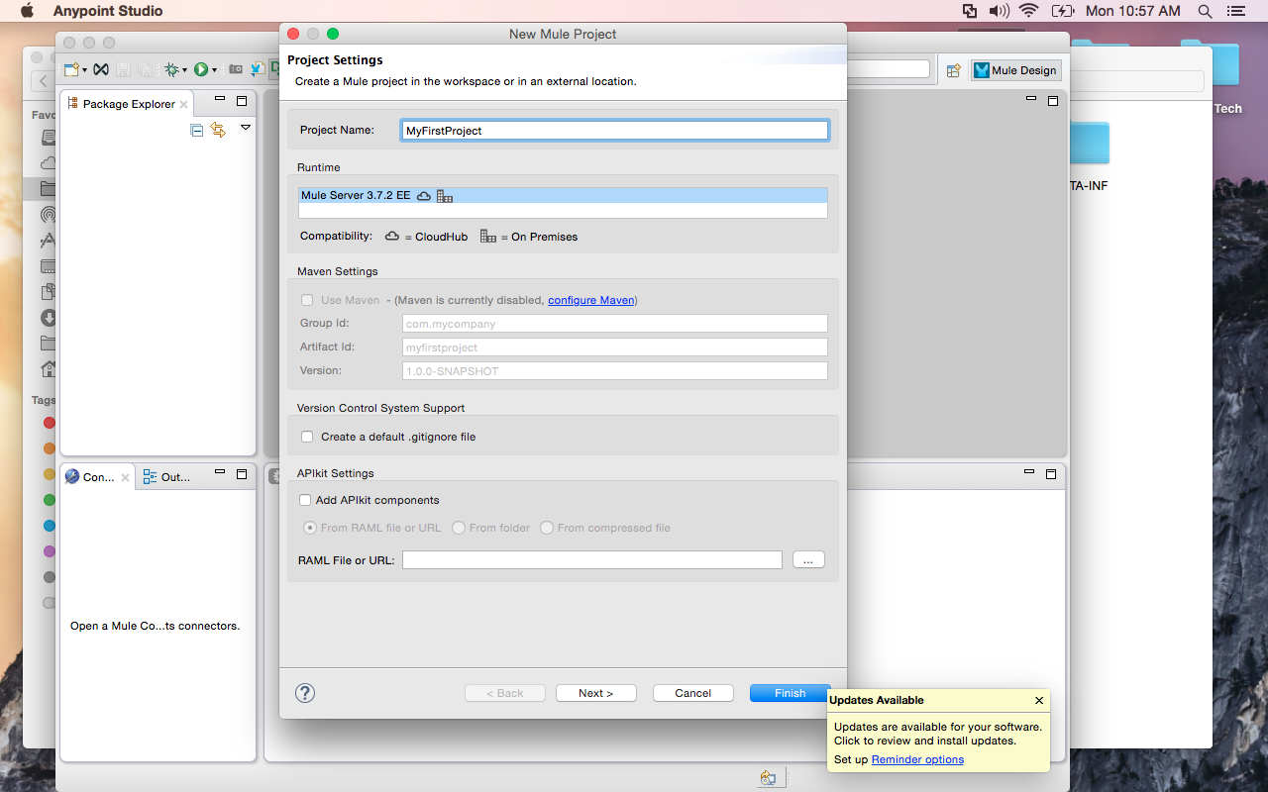

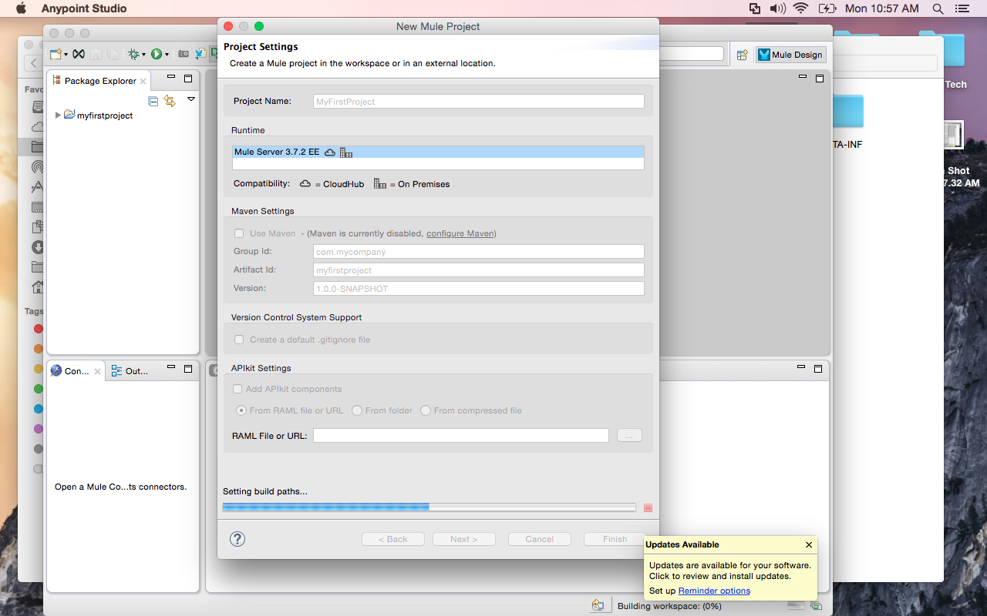

2. Studio opens a new blank project, below is  a quick reference of the different views you use to build a Mule project.

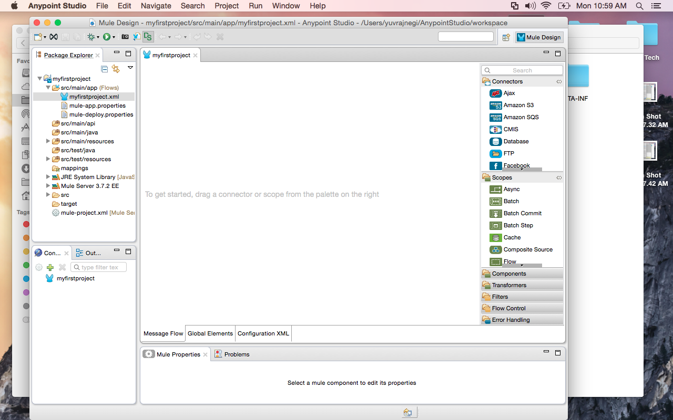

3. Start designing your project by dragging and dropping an **HTTP Connector** from the **palette** onto the **canvas**.

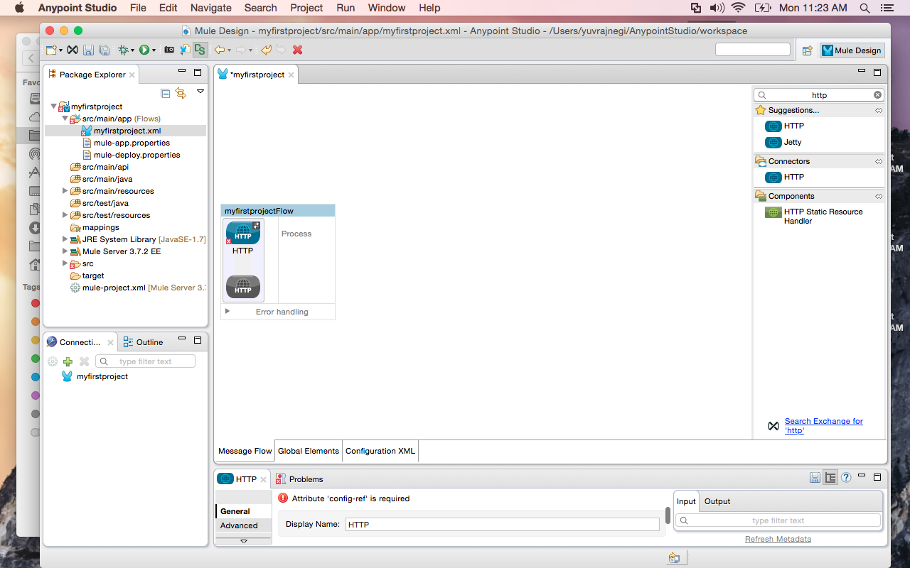

4. Add a Set Payload Component to your flow.

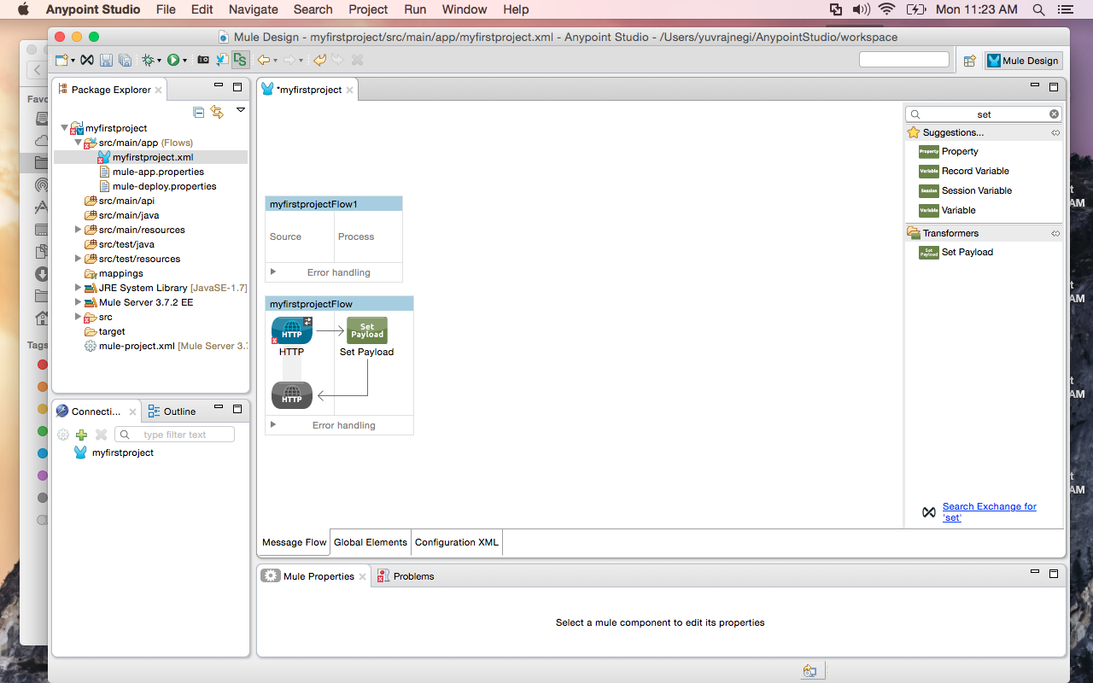

5. Click the **Configuration XML** tab to see your application represented in XML.

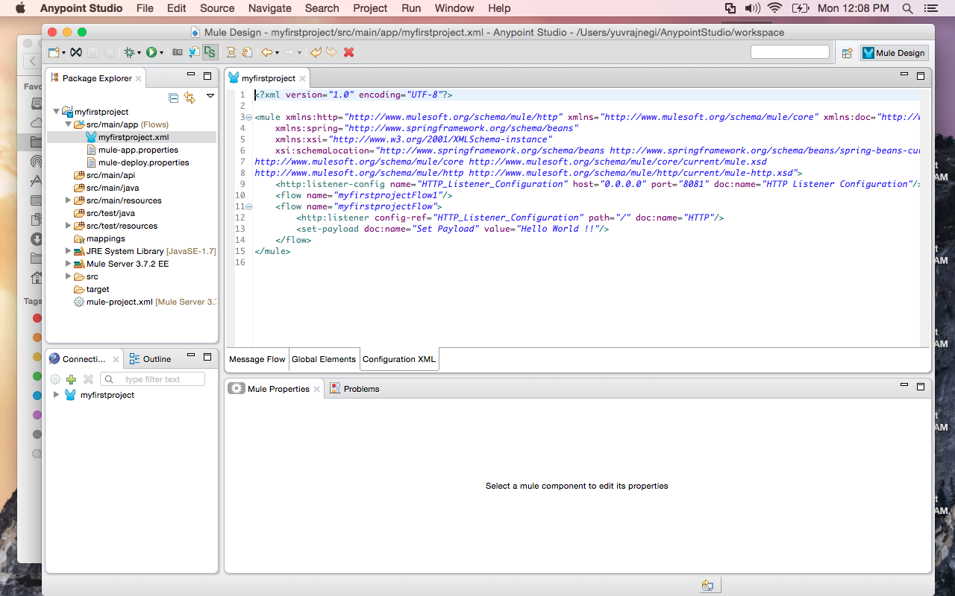

## **Configuring the Project**

1. Click the HTTP Connector on the canvas to open its **Properties Editor.** The HTTP Connector allows your Mule application to connect to Web resources through the HTTP protocol.

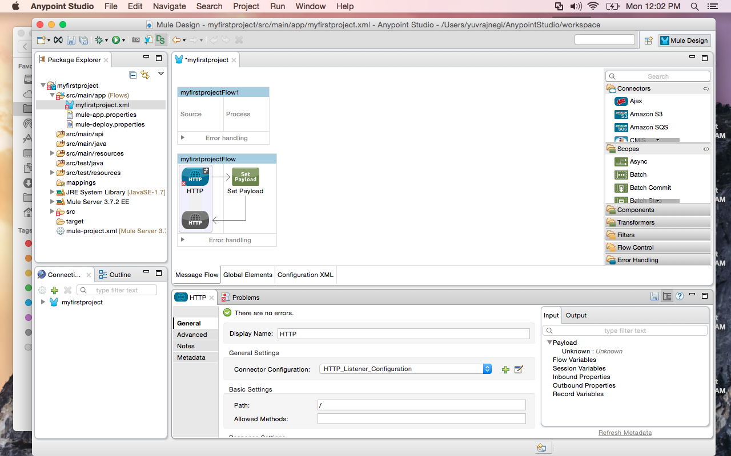

2. Click the green plus sign (+) next to **Connector Configuration** to create a new**Global Element** to be referenced by the connector.

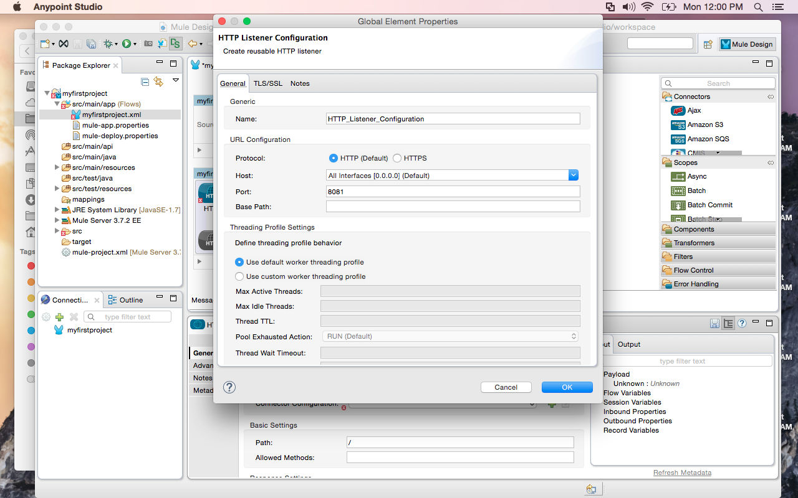

4. Click the **Set Payload Component** on the canvas to open its **Properties Editor** in the console.

5. The Set Payload Component simply sets the message payload to a value you define. Set the **Value** field to Hello World!!

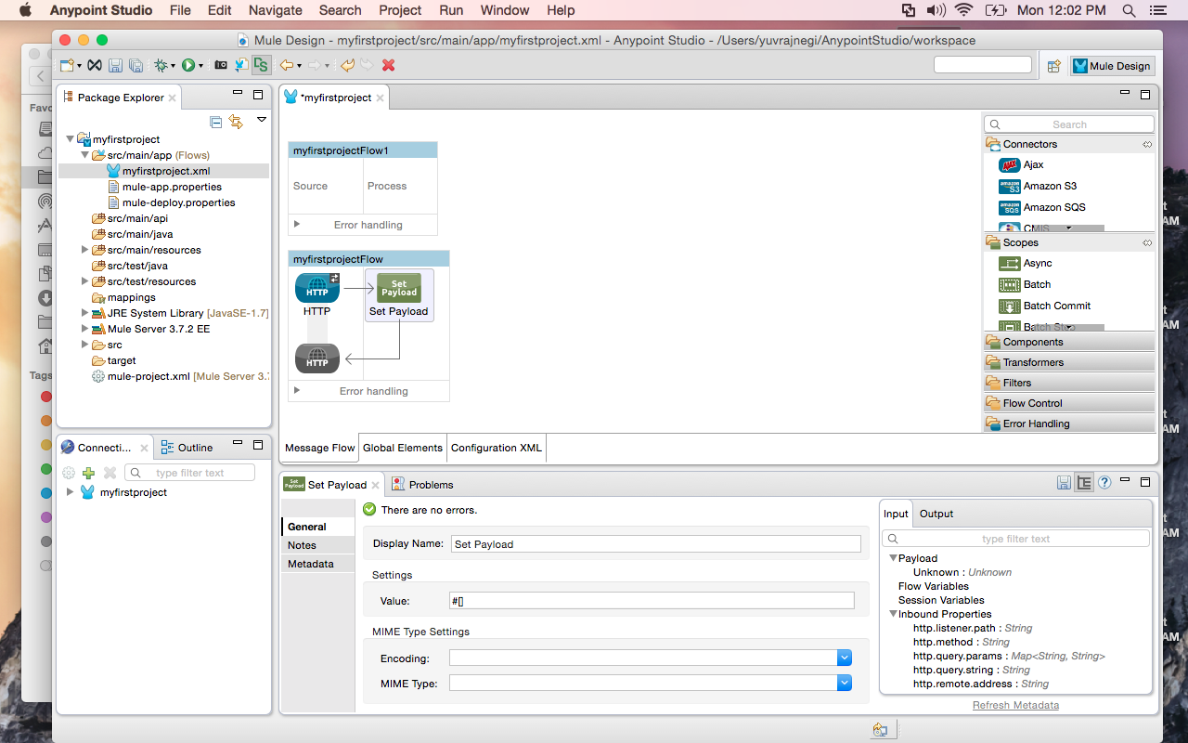

6. Once again, click the **Configuration XML** to view your changes in the XML config.



## **Deploying the Project**

1. In the **Package Explorer**, right-click the project name, then select **Run As** > **Mule Application**.

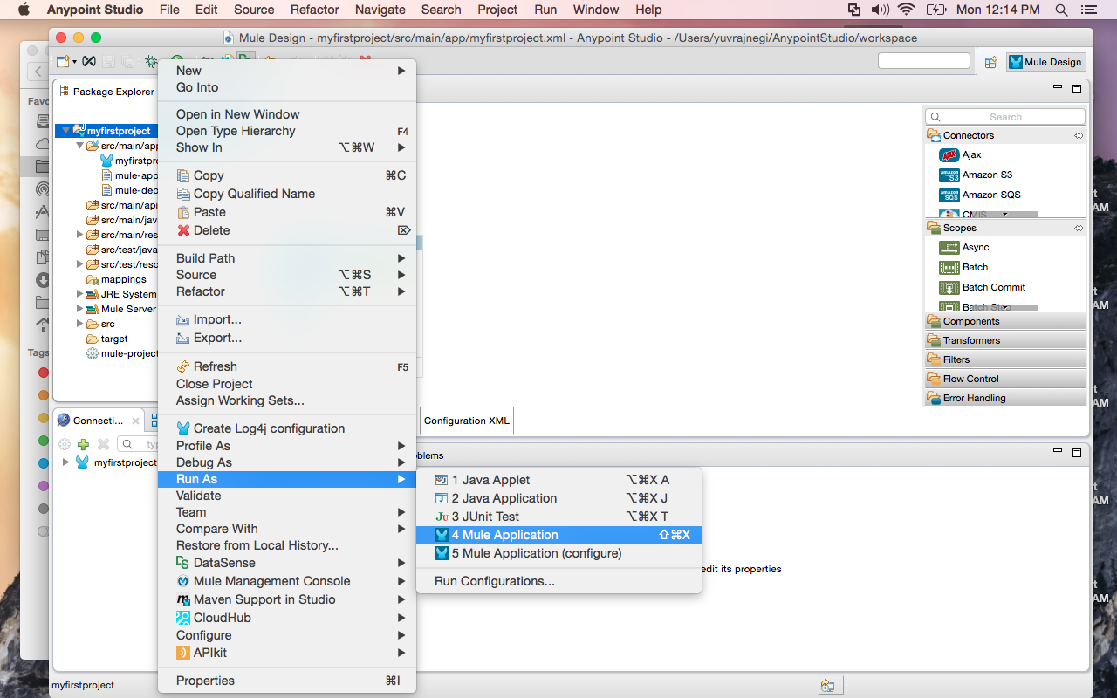

2. Studio launches the application on the server, displaying its actions in the console. When complete, the console message reads: Started app 'my_first_project'

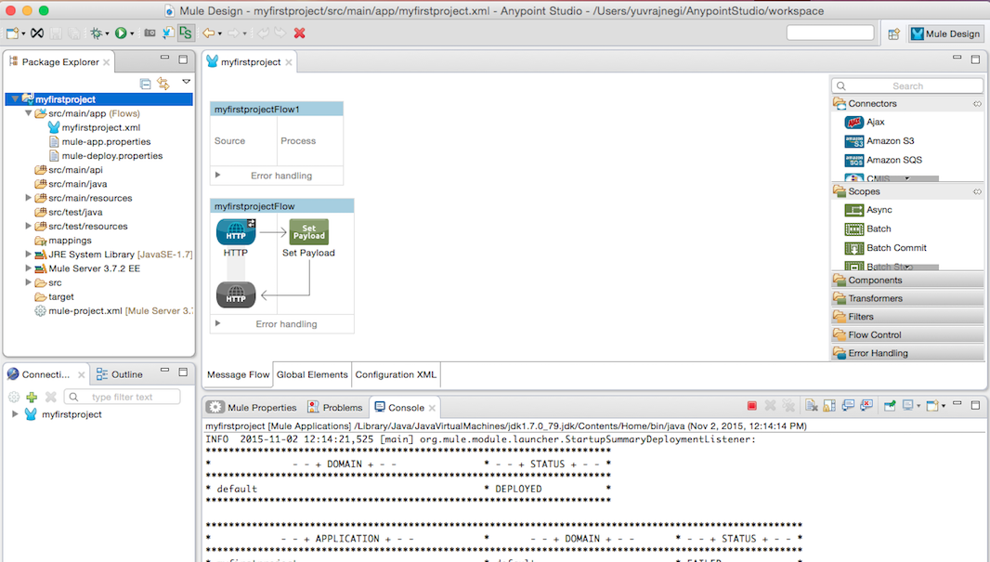

## **Interacting with the Project**

1. Open a Web browser.

2. Navigate to the URL of your application. [http://localhost:8081](http://localhost:8081/)

# Using Git with Studio

## Installing the Git Plugin

1. In Studio, click the **Help** menu, then select **Install New Software.**

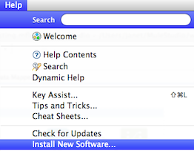

2. In the **Work with** field of the **Available Software** panel, use the drop-down menu to select

Egit Update Site - http://download.eclipse.org/egit/updates-2.1

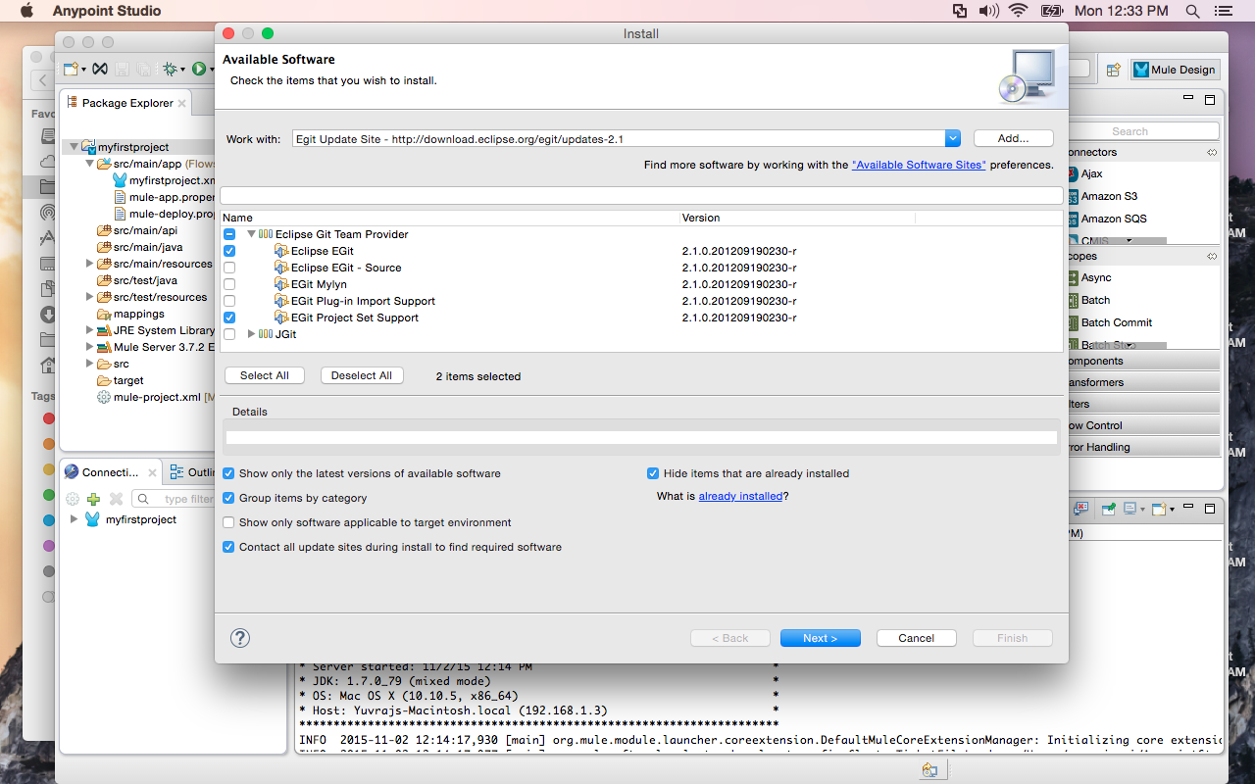

3. In the table below the **Work with** field, click the check boxes associated with**Eclipse Git Team Provider** and **JGit**.

4. Click **Next** to continue.

5. In the **Install Details** panel, click **Next** to continue installation.

6. In the **Review Licenses** panel, select **I accept the terms of the license agreement**, then click **Finish**.

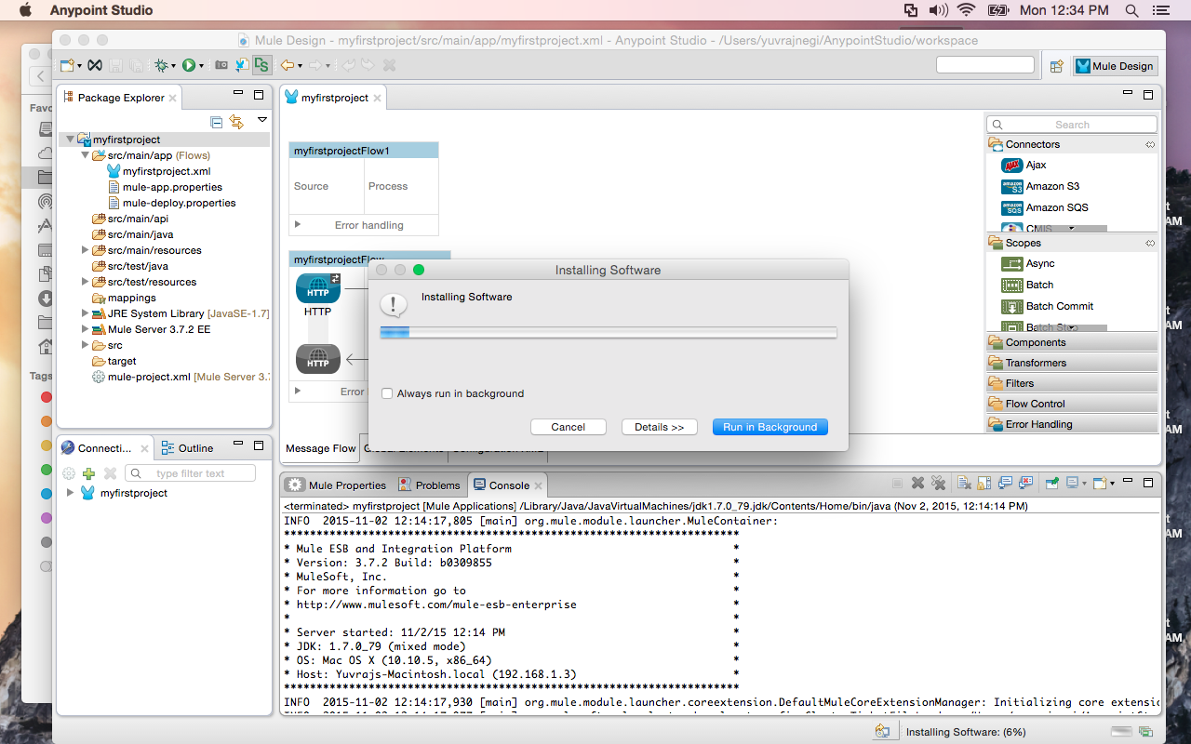

7. Click **Restart Now** to complete the installation and restart Studio.

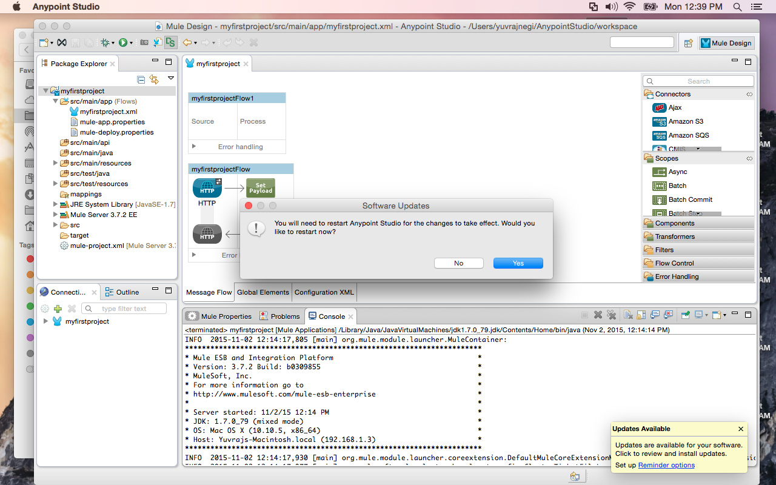

**Referencing link for git:**

<https://github.com/sjsu-cmpe272/CMPE272_MuleProject_HW_Assignment-8_ShaliniNegi/tree/master>